TOURISM INDUSTRY
Economic Impact of COVID-19

MINOR PROJECT REPORT
Subject: data science using lab excel
Submitted by:
Student Name: SAKSHAM CHANANA
UID: 26BCD10374
Student Name: BASEERAT TANTRAY
UID: 26BCD399
Section: [bcd6B]
Submitted to: {SIMRANJEET SINGH}

1. Abstract
The Tourism Industry: Economic Impact of COVID-19 project studies how the COVID-19 pandemic affected the global tourism industry between 2019 and 2023. COVID-19 spread worldwide in 2020, and many countries closed their borders and restricted travel. As a result, hotels, beaches and tourist destinations became empty. The project uses Microsoft Excel to record yearly data on international tourist arrivals, tourism earnings and tourism jobs. It then calculates the percentage fall in each of these during 2020 and shows the results in charts. Microsoft Word is used to prepare the project report, and Microsoft PowerPoint is used to present the findings. The data are rounded figures based on public reports from UN Tourism (UNWTO) and the World Travel & Tourism Council (WTTC). The project shows how spreadsheet-based data analysis can turn raw figures into a clear picture of a global economic crisis and the slow recovery that followed.

2. Demo and Code
Demonstration
The project was implemented using Microsoft Excel. The workbook contains a data table for the years 2019 to 2023 with four columns: Year, Tourist Arrivals (Billion), Tourism Earnings (USD Billion) and Tourism Jobs (Million).

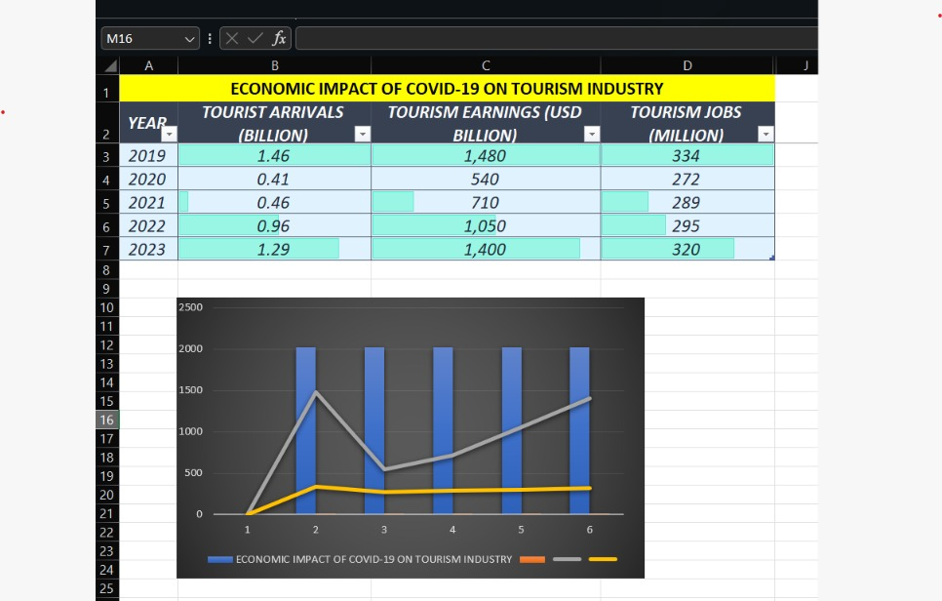
Below the table, formulas calculate the percentage drop in 2020 compared with 2019. Three charts show the trends: a line chart for tourist arrivals, a column chart for earnings and a bar chart for jobs. The charts clearly show the sharp fall in 2020 and the slow climb back up in the following years.
Excel Formulas Used
- Percentage Drop in Tourist Arrivals (2020)
=(B3-B2)/B2*100
This formula subtracts the 2019 arrivals from the 2020 arrivals, divides by the 2019 value and multiplies by 100. The result is about -72%.
- Percentage Drop in Tourism Earnings (2020)
=(C3-C2)/C2*100
This formula finds the percentage change in earnings from 2019 to 2020. The result is about -64%.
- Percentage Drop in Tourism Jobs (2020)
=(D3-D2)/D2*100
This formula finds the percentage change in jobs from 2019 to 2020. The result is about -19%.
A negative result means a fall compared with 2019, and a positive result would mean growth.
.

3. Project Objectives
The main objective of this project is to study how COVID-19 damaged the tourism industry and how the industry slowly recovered afterwards.
The specific objectives of the project are:
- Understand the Impact: To find out how COVID-19 hurt the tourism business around the world.
- Measure Tourist Losses: To count how many international tourists were lost in 2020 compared with 2019.
- Measure Financial Losses: To calculate how much tourism income was lost during the pandemic.
- Measure Job Losses: To find out how many tourism jobs were lost.
- Study the Recovery: To see how tourism slowly came back after 2021 and by how much it had recovered by 2023.
- Apply Excel Formulas: To use percentage-change formulas to turn raw numbers into meaningful results.
- Visualize the Data: To present the data through line, column and bar charts so that trends are easy to understand.
- Learn from the Crisis: To understand why tourism businesses need emergency savings and planning.
The project aims to present a simple and clear picture of the pandemic’s effect on tourism using easy-to-understand data and charts.

4. Technologies Implemented
The project uses three Microsoft Office applications. Microsoft Excel is used for data and calculations, Microsoft Word is used for the report, and Microsoft PowerPoint is used for the presentation.
4.1 Microsoft Excel
Microsoft Excel is the main tool used in this project. It stores the tourism data in a simple table, applies formulas and creates charts.
The following Excel features are used:
- Data Entry: Records the year, tourist arrivals, tourism earnings and tourism jobs.
- Formulas: Calculate the percentage drop in arrivals, earnings and jobs for 2020.
- Cell References: Connect the formulas to the values in the data table.
- Charts: A line chart, a column chart and a bar chart show how each measure changed from 2019 to 2023.
- Table Formatting: Headings and clean formatting make the data easier to read.
4.2 Microsoft Word
Microsoft Word is used to write the research report. It provides tools for formatting headings, paragraphs, numbered lists, formulas, tables, screenshots and figure captions. The report documents the project’s objectives, technologies, features, development process and conclusion.
4.3 Microsoft PowerPoint
Microsoft PowerPoint is used to present the findings. It shows the main results using big numbers, simple points and pictures of the charts, so that the audience can understand the project quickly.
4.4 Data Source
The data come from public reports published by UN Tourism (UNWTO) and the World Travel & Tourism Council (WTTC). The figures are rounded, and the values for 2021 and 2022 are approximate. The project does not use any private or survey data.

5. Project Features
The project has several features that make the impact of COVID-19 on tourism easy to understand.
5.1 Simple Data Table
The Excel sheet contains a simple table with figures for 2019 to 2023. It covers three measures: tourist arrivals, tourism earnings and tourism jobs.
5.2 Percentage Drop Calculation
Excel formulas automatically calculate how much each measure fell in 2020 compared with 2019. If a value in the table changes, the result updates.
5.3 Tourist Arrivals Analysis
International tourist arrivals fell from 1.46 billion in 2019 to 0.41 billion in 2020, a fall of about 72%. This was the biggest drop of the three measures.
5.4 Earnings Analysis
Tourism earnings fell from USD 1480 billion in 2019 to USD 540 billion in 2020, a fall of about 64%. This shows how much money the industry lost when people stopped travelling.
5.5 Jobs Analysis
Tourism jobs fell from 334 million in 2019 to 272 million in 2020, a loss of about 62 million jobs, or about 19%. The fall in jobs was smaller than the fall in arrivals because many workers were kept on through government support and temporary measures.
5.6 Recovery Analysis
By 2023, arrivals had reached 1.29 billion, earnings had reached USD 1400 billion and jobs had reached 320 million. This is roughly 88% of the 2019 arrivals, 95% of the 2019 earnings and 96% of the 2019 jobs.
5.7 Chart Visualization
A line chart shows the arrivals trend, a column chart shows earnings and a bar chart shows jobs. These charts make the big fall in 2020 and the slow climb back up easy to see.
5.8 Easy Language and Key Facts
The project uses easy words and big key facts, so that anyone can understand it without a background in economics.
Overall, the project combines a small dataset, simple formulas and clear charts to show the effect of COVID-19 on tourism.

6. Development Process
The project was developed in the following steps.
6.1 Choosing the Topic
The tourism industry was chosen because it was one of the sectors hit hardest by COVID-19. Travel bans and border closures affected hotels, airlines, beaches and tourist places worldwide.
6.2 Data Collection
Data on tourist arrivals, tourism earnings and tourism jobs for 2019 to 2023 were collected from reports published by UN Tourism (UNWTO) and the World Travel & Tourism Council (WTTC). The figures were rounded to keep the dataset simple.
6.3 Creating the Excel Table
The data were entered into an Excel worksheet with four columns: Year, Tourist Arrivals (Billion), Tourism Earnings (USD Billion) and Tourism Jobs (Million). Clear headings were added.
6.4 Applying Formulas
Percentage-change formulas were added below the table. The label “% Drop in Tourists 2020” was typed in cell A8, and the formula =(B3-B2)/B2*100 was entered in cell B8. Similar formulas were used for earnings and jobs.
6.5 Creating Charts
The table was selected and charts were inserted using the Insert tab. A line chart was made for tourist arrivals, a column chart for earnings and a bar chart for jobs.
6.6 Preparing the Report
The report was written in Microsoft Word. It includes the abstract, objectives, technologies, features, development process and conclusion, along with screenshots of the Excel sheet and charts.
6.7 Preparing the Presentation
The charts were copied into Microsoft PowerPoint, and the main findings were put on seven slides with three short points each.
6.8 Checking the Results
The calculated percentages were checked against the table values to make sure the formulas gave the expected results. The source figures were also compared with the UNWTO and WTTC reports.
The development process shows how a simple dataset, a few formulas and clear charts can turn raw figures into useful findings.

7. Conclusion
This project shows how severely COVID-19 affected the global tourism industry. In 2020, international tourist arrivals fell by about 72%, and tourism earnings fell by about 64%, a huge loss of money. About 62 million tourism jobs were lost, which is a fall of about 19%.
The data also show that tourism started to recover after 2021. By 2023, arrivals, earnings and jobs were close to their 2019 levels, although arrivals were still about 12% below them. This shows that the industry is strong, but that recovery takes several years.
The project also shows how Microsoft Excel formulas and charts can turn raw data into clear findings. Microsoft Word was used to document the work, and Microsoft PowerPoint was used to present it.
The figures used in this project are rounded and approximate, especially for 2021 and 2022, so they should be treated as an illustration rather than exact official statistics.
In conclusion, the pandemic taught tourism businesses that they need emergency savings and good planning to survive sudden crises. Future work could include data for individual countries, the effect on airlines and hotels, and how digital tools helped the industry recover.

